# TITLE:

# Contributions of human activities to suspended sediment yield during storm events from a steep, small, tropical watershed

## ABSTRACT

Abstract text goes here....

## Introduction

Introduction text goes here....

## Study Area

Study Area text goes here....



Figure 1. Faga'alu and Nu'uuli watersheds showing upper (undisturbed) and lower (human-disturbed) subwatersheds.

|  |  |  |  |  |  |  |  |  |
| --- | --- | --- | --- | --- | --- | --- | --- | --- |
| Table 1. Land use categories in Fag'alu and Nu'uuli watersheds CITATION | | | | | | | | |
| Subwatershed | Cumulative Area km2 | % | % High Intensity Developed | % Developed Open Space | % Grassland (agriculture) | % Forest | % Scrub/ Shrub | % Bare Land |
| FOREST(UPPER) | 0.9 | 48.2 | 0.0 | 0.0 | 0.1 | 82.4 | 17.1 | 0.4 |
| QUARRY | 1.17 | 63.0 | 0.2 | 0.0 | 0.2 | 84.7 | 13.3 | 1.6 |
| VILLAGE(TOTAL) | 1.78 | 95.5 | 3.2 | 0.9 | 0.2 | 85.7 | 9.0 | 1.1 |
| Fagaalu Stream | 1.86 | 100.0 | 4.6 | 1.1 | 0.2 | 84.5 | 8.6 | 1.0 |

Quarry description text goes here...



Figure 2. Photos of the open-pit aggregate quarry in Faga'alu in 2012 (Top) and 2014 (Bottom). Photo: Messina

## Methods

Methods text goes here...

## Results

### Field Data Collection

#### Precipitation

Precipitation text goes here...

#### Water Discharge

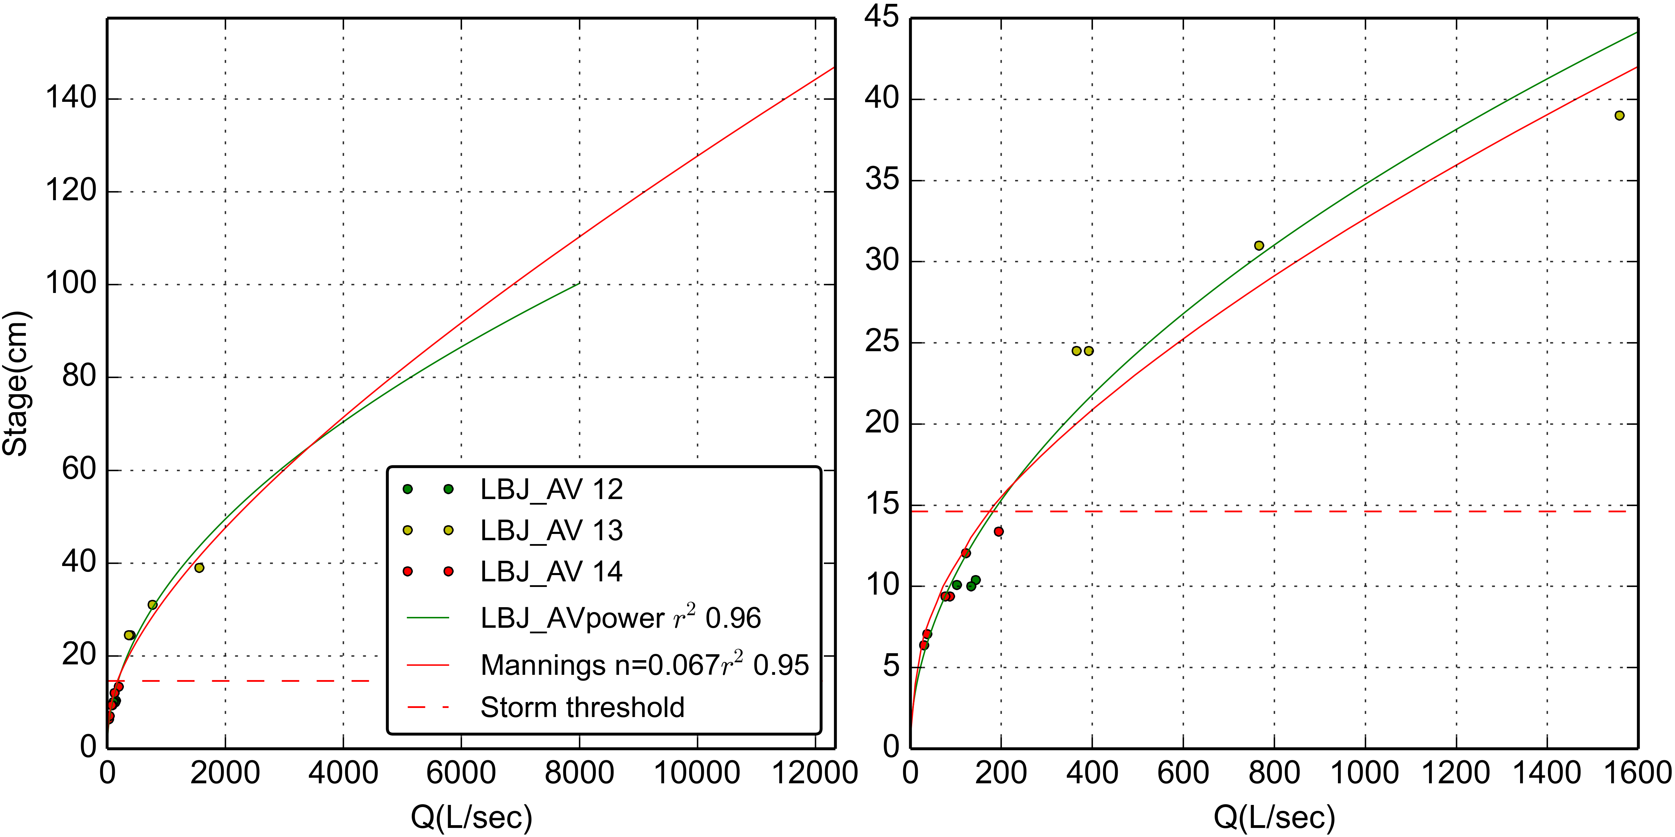

Figure 3. Stage-Discharge relationships for stream gaging site at VILLAGE.

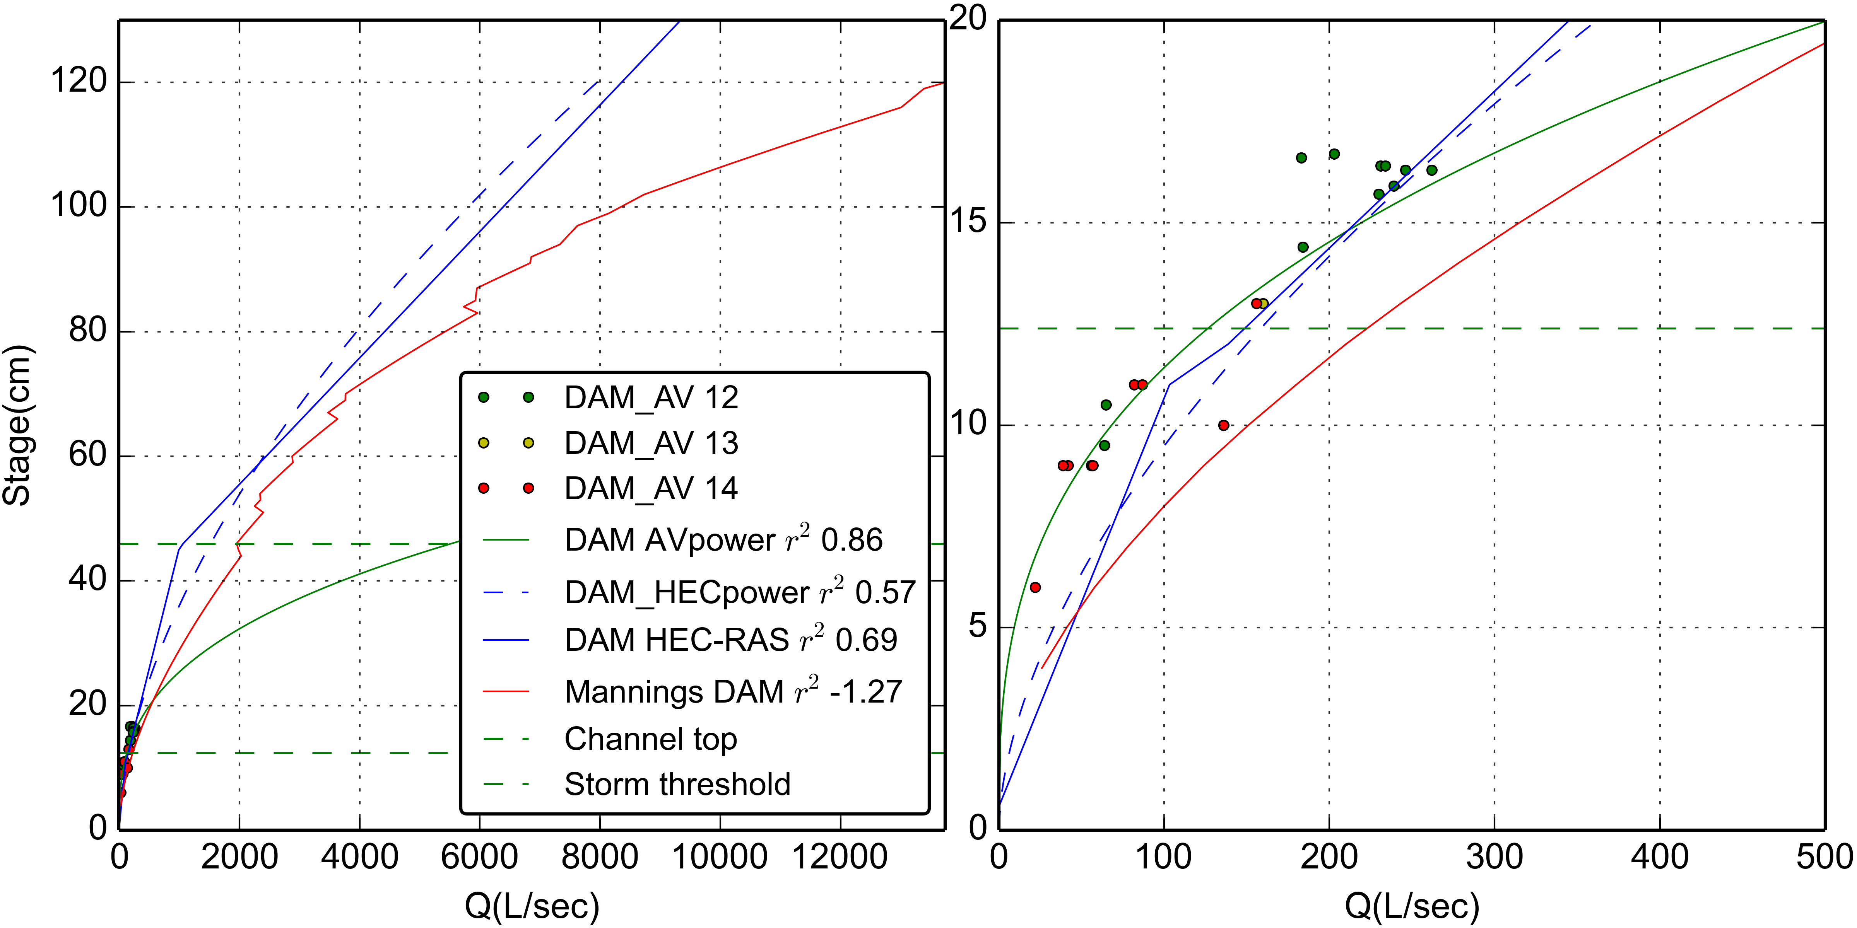

Figure 4. Stage-Discharge relationships for stream gaging site at FOREST.

#### Suspended Sediment Concentration

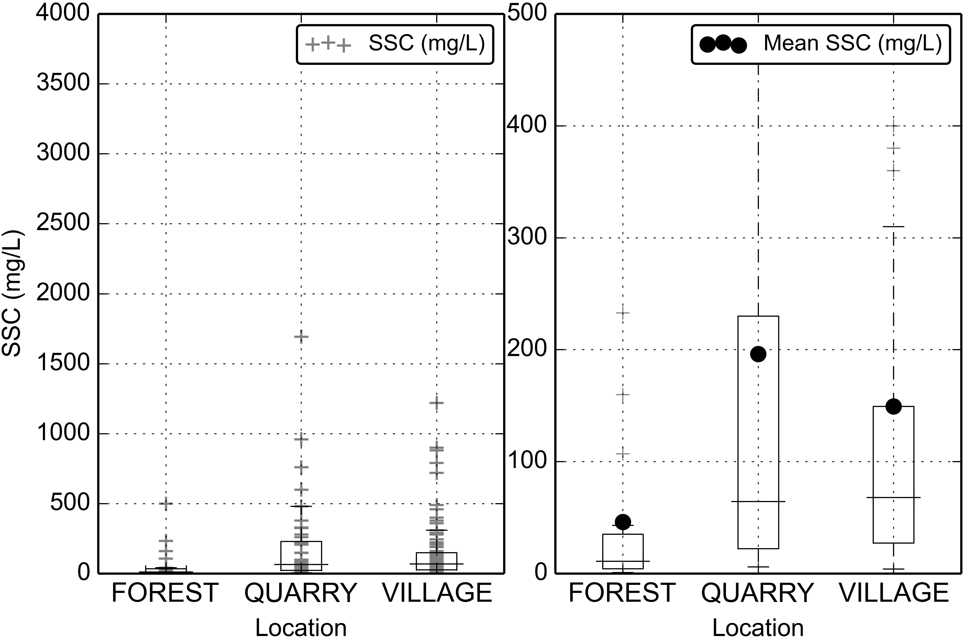

Figure 5. Boxplots of Suspended Sediment Concentration (SSC) at FOREST, QUARRY, and VILLAGE during storm periods.

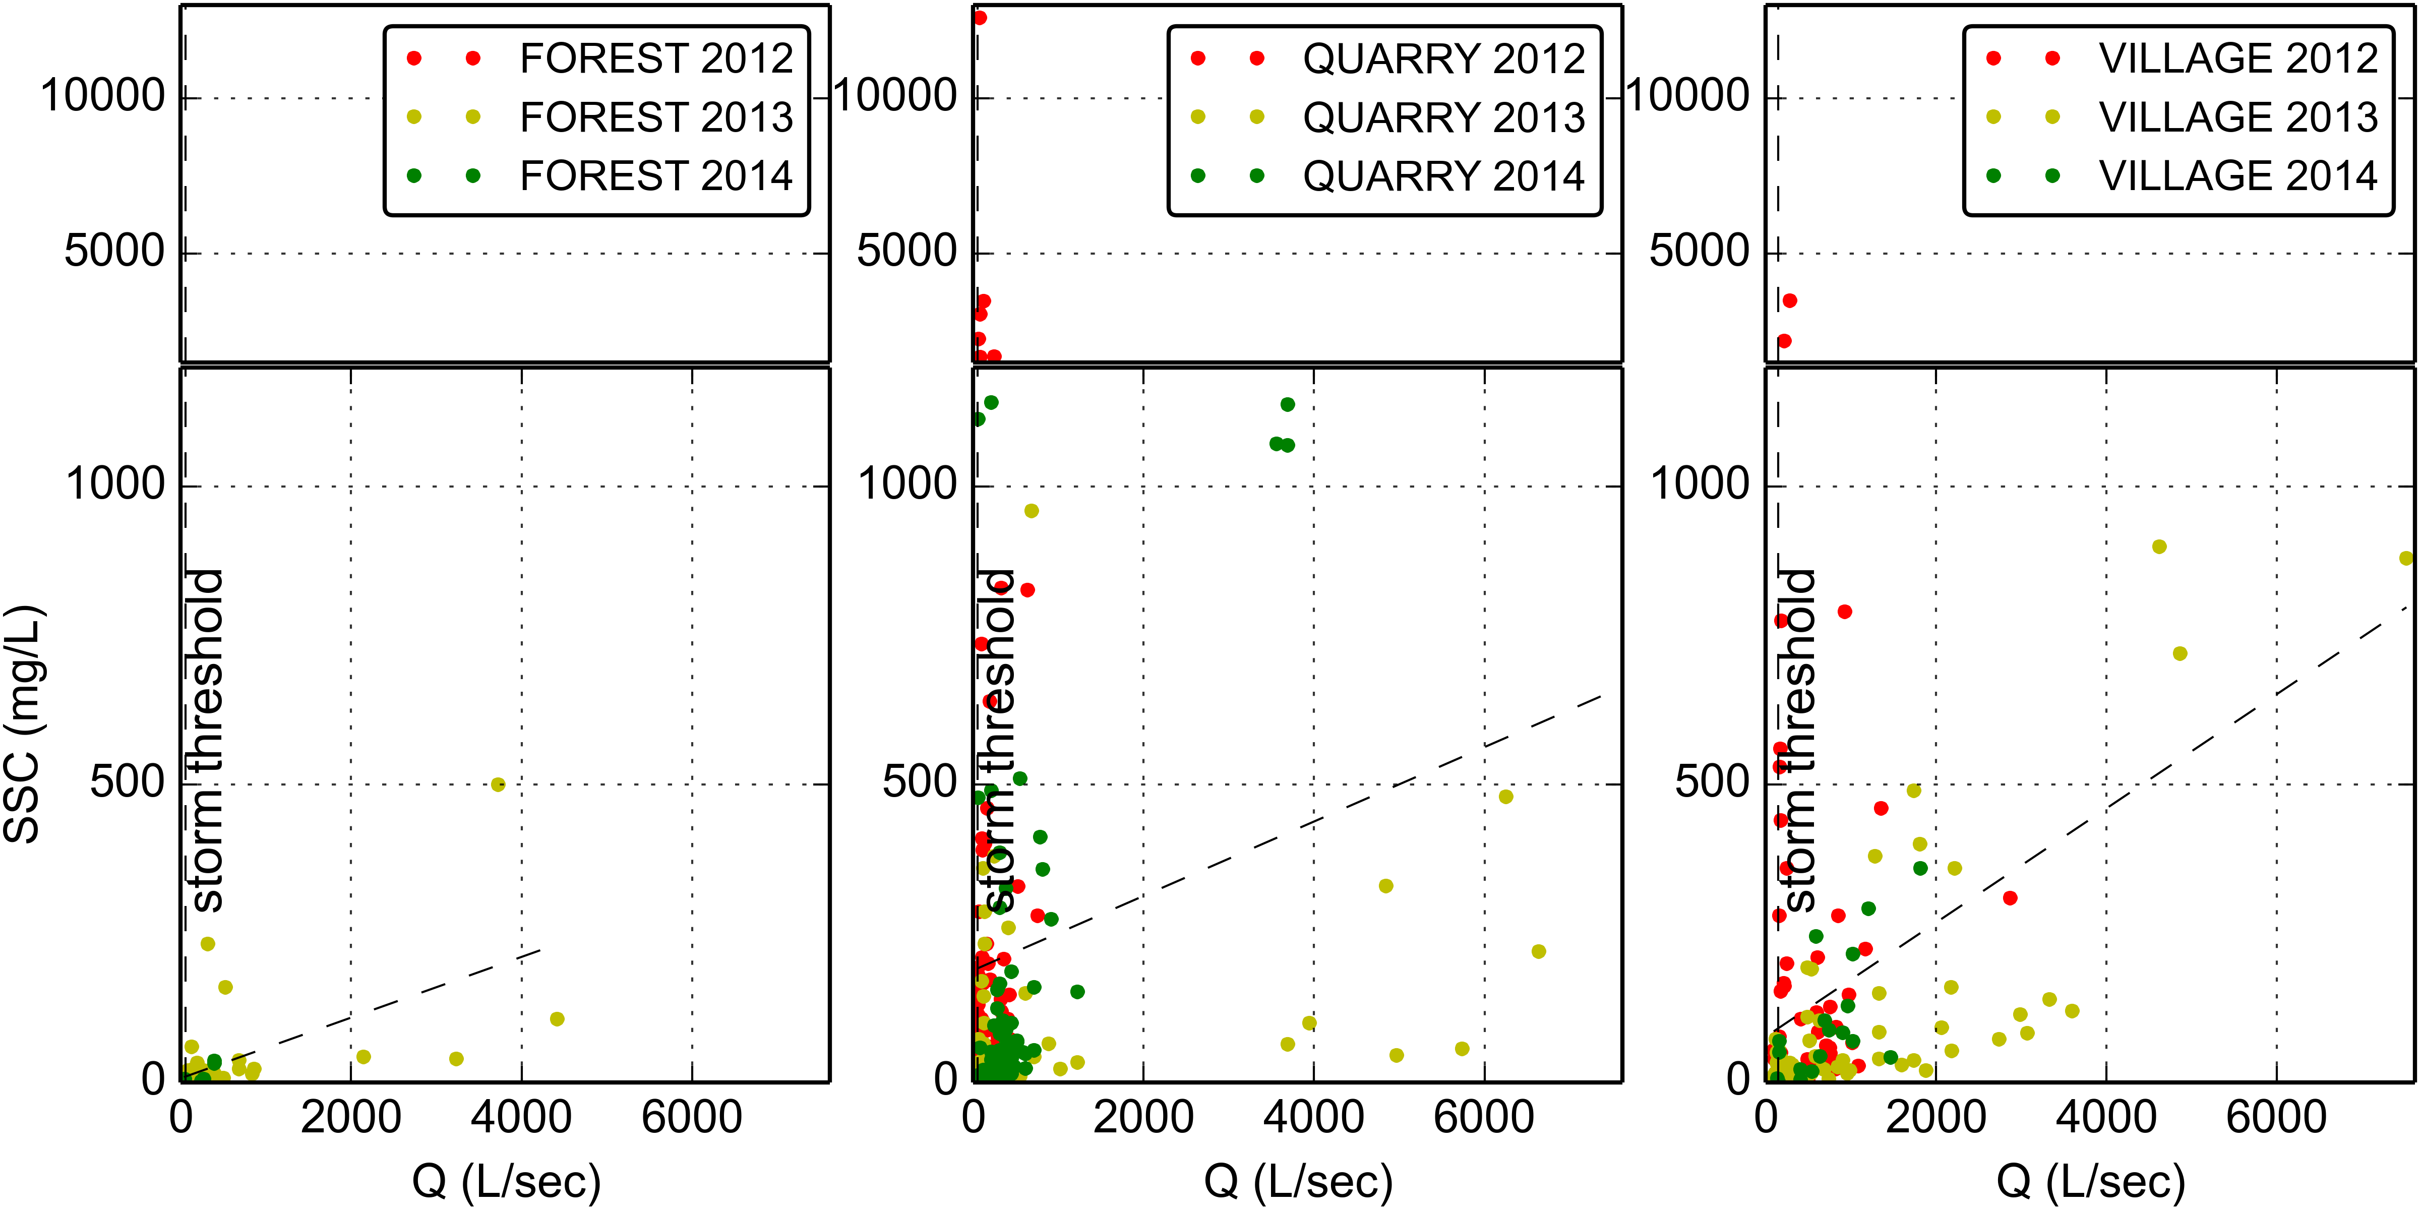

Figure 6. Water Discharge vs Suspended Sediment concentration at FOREST, QUARRY, and VILLAGE during baseflow and stormflow.

#### Turbidity

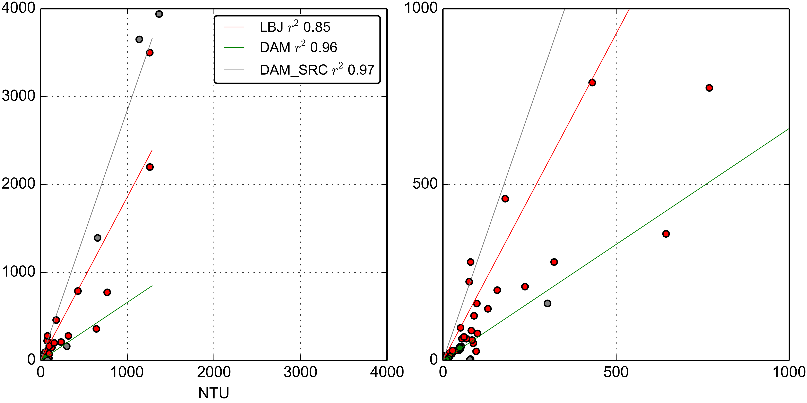

Figure 7. Turbidity-Suspended Sediment Concentration relationships for the YSI turbidimeter deployed at VILLAGE (2012-02-27 13:00:00-2012-05-23 14:00:00) and at FOREST (2013-06-13 14:30:00-2014-12-31 00:00:00).

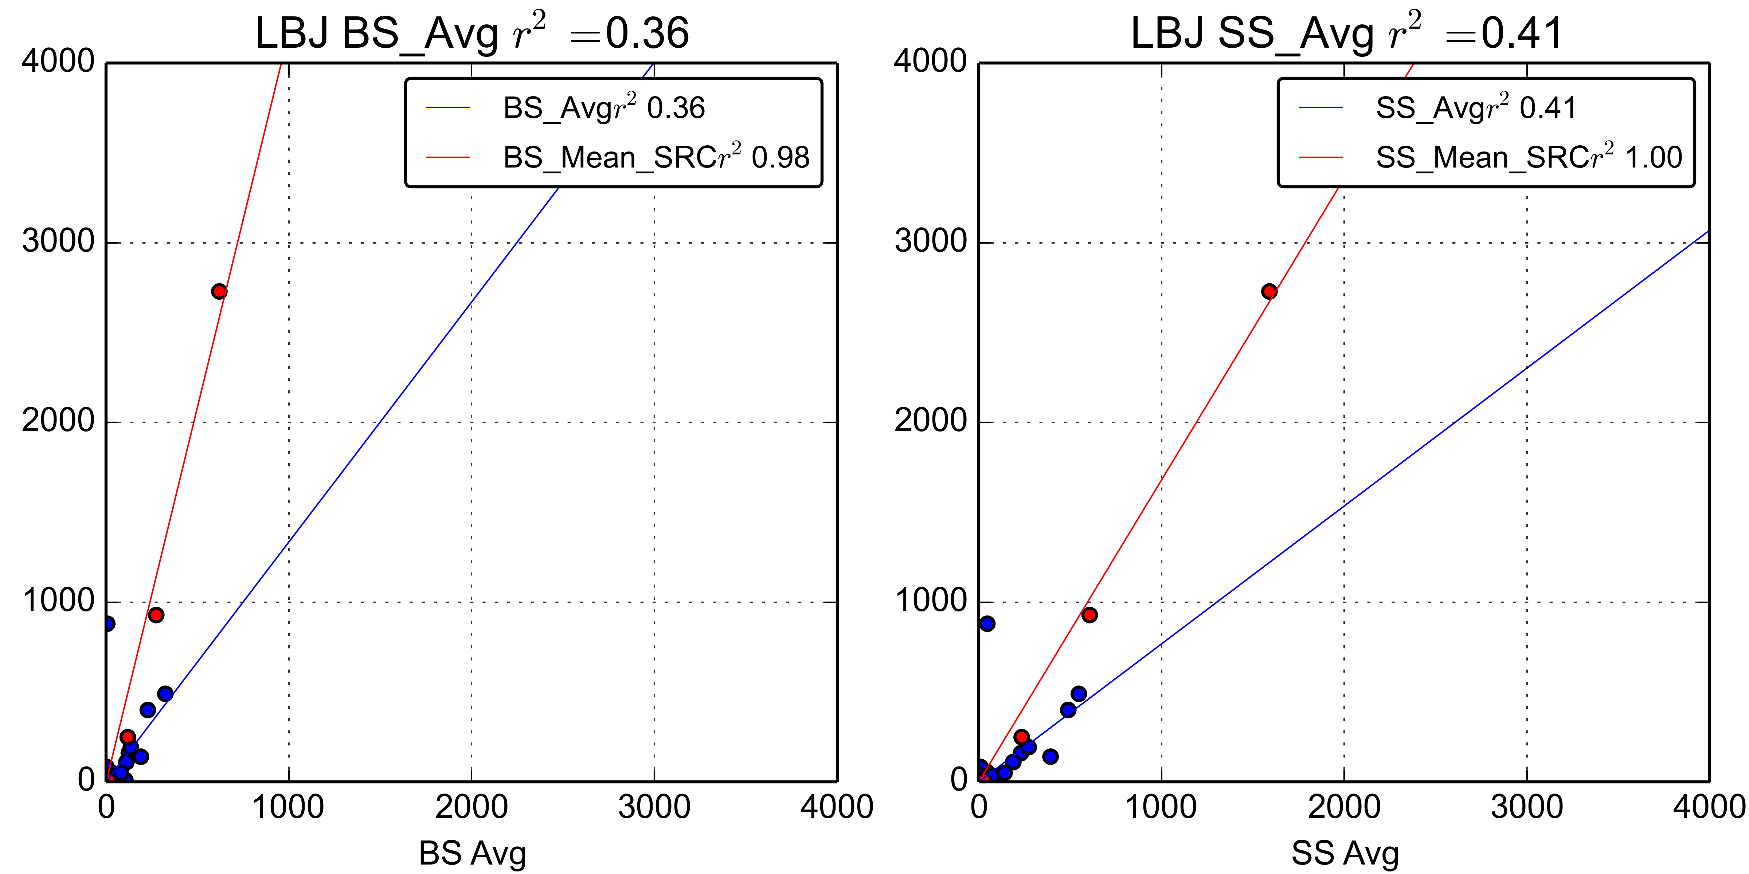

Figure 8. Turbidity-Suspended Sediment Concentration relationships for the OBS500 turbidimeter deployed at VILLAGE (2013-03-07 14:25:00-2013-07-15 14:35:00).

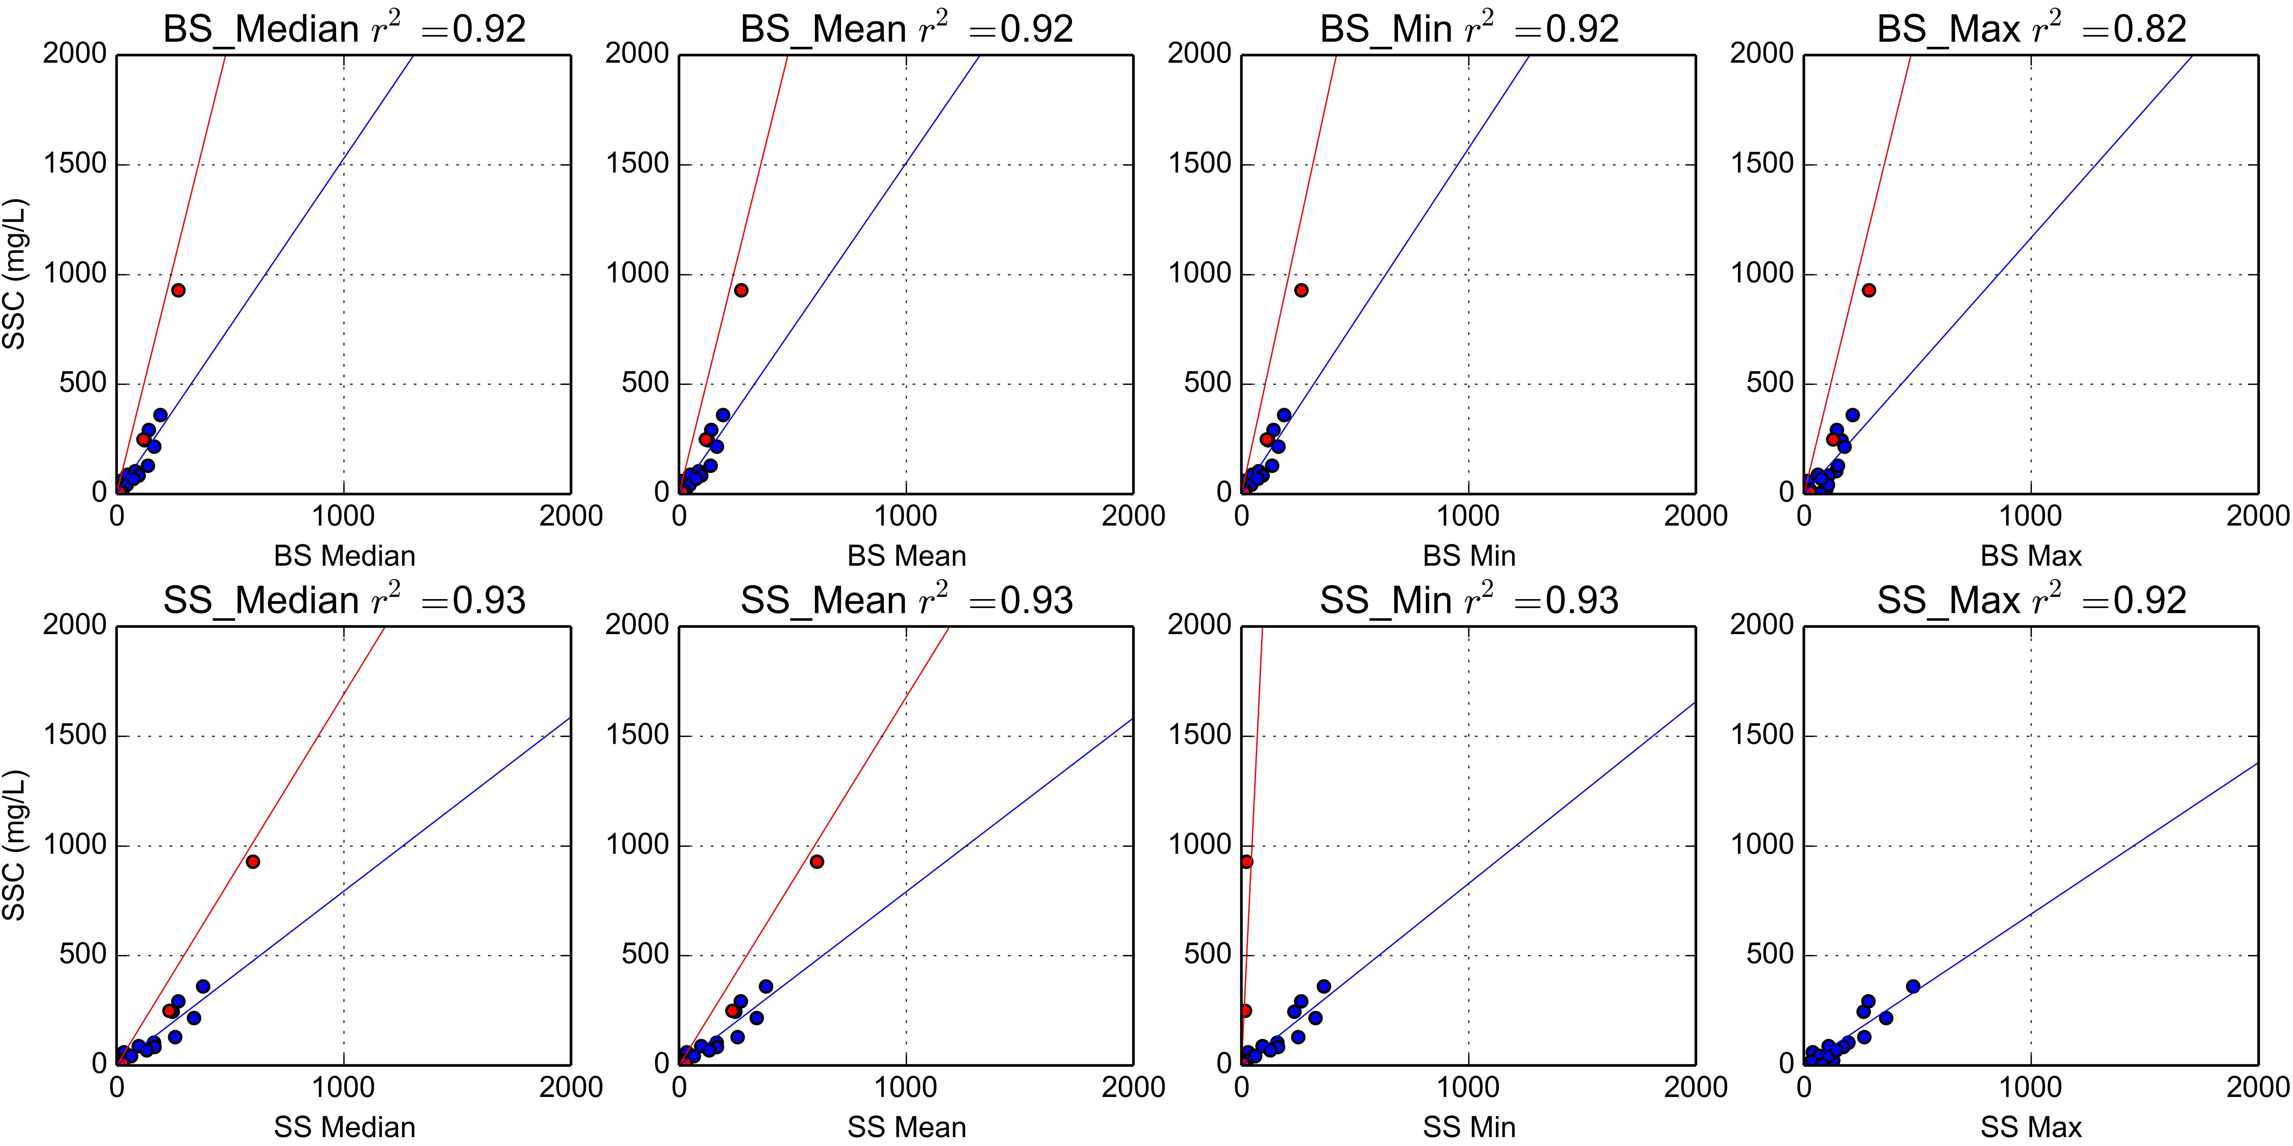

Figure 9. Turbidity-Suspended Sediment Concentration relationships for the OBS500 turbidimeter deployed at VILLAGE (2014-01-31 14:30:00-2014-03-04 09:15:00).

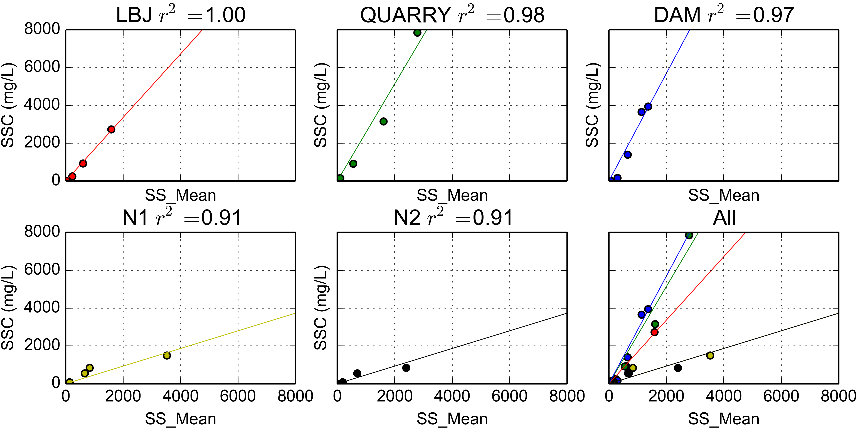

Figure 10. Synthetic Rating Curves for Turbidimeters deployed at FOREST, QUARRY, VILLAGE, Nuuuli1 and Nuuuli2

### Storm Events

### Comparing SSY from disturbed and undisturbed subwatersheds

### Disturbance Ratio

### Comparing predictors of SSY

### Fitting sediment curves

### Comparing human impact on SSY from Faga'alu watershed

## Discussion

Discussion text goes here...

## Conclusion

Conclusion text goes here...